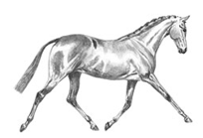
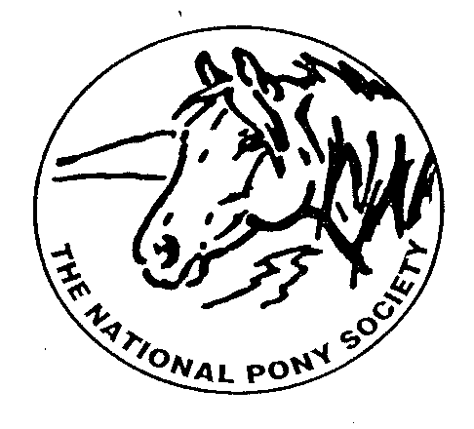
NPS SCOTLAND

MEET OUR BURSARY AWARD WINNERS 2026

The committee of NPS Scotland decided to award the Annual Bursary Awards within the 3 classes of the Junior Ridden section of the NPS Scotland Championships at Scone Palace International Horse Trials.
Our judge Jennifer Adams selected her winner from each class who was then awarded a fabulous sash and a voucher for £150 towards further training and education from NPS Scotland.
BURSARY WINNER – Jack Johnston Ireland riding Tinny-Timy
LARGE BREEDS (Not exceeding 138cms) riders under 18 years - Class 25
Hello, my name is Jack, and I am a member of Inverness- shire Pony Club. My pony Timmy and I attend Rallies, Camps and have competed in teams for the Caroline Cup and other Pony Club events. Timmy and I recently competed at The Black Isle then Grantown Agricultural Shows, we were placed at both competitions and took home Reserve Champion from Grantown,
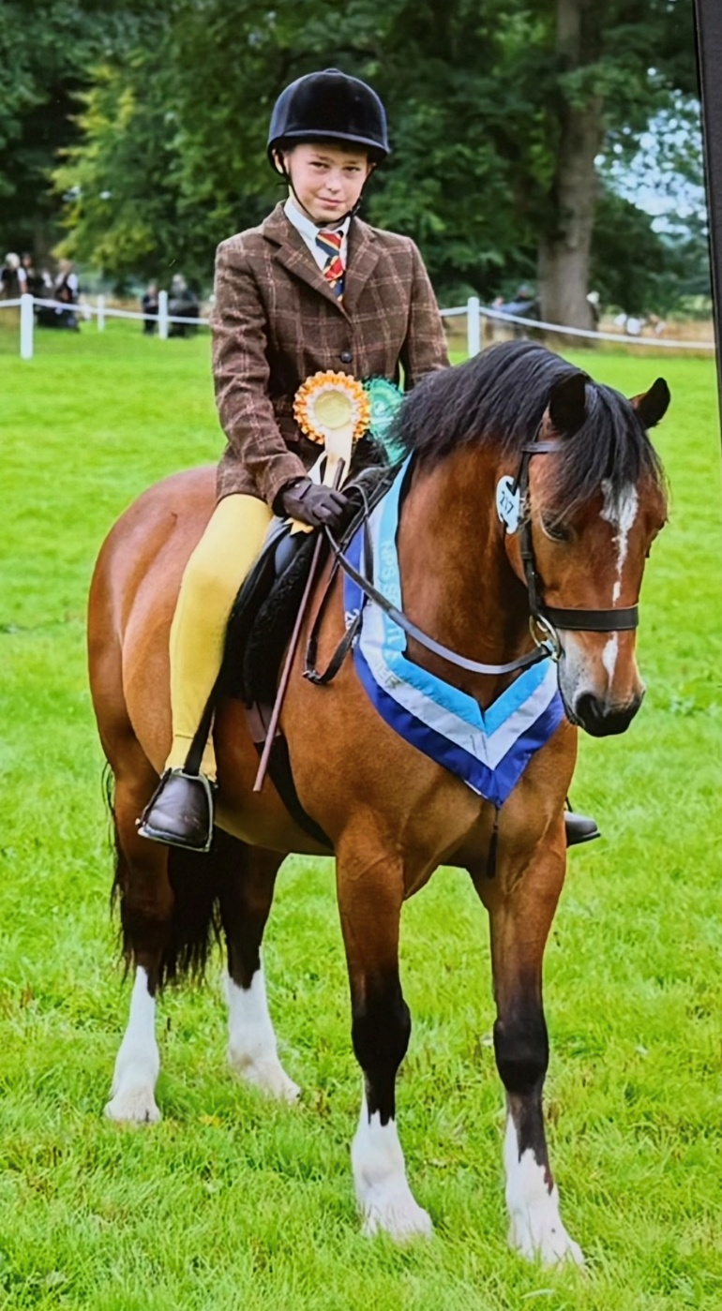
Timmy and I enjoy showjumping, Ridden, Working Hunter and x country. We are entered in The North Cup competition on the 12th September at Scotsburn home of Ross-shire pony club and are practicing for this event which is a ODE, Dressage showjumping and x country.
I was so shocked and excited when my name & number was called out at scone as the winner of the Bursary Award. Timmy is the best pony ever he is amazing and looks after me so well . He was given extra treats and hugs after winning this award on Friday. We will be spending the Bursary on flat work lessons and show jumping lessons. We hope to book these lessons with James Munro who teaches at UHI North College at Halkirk in Caithness.
Thank you so much for selecting Timmy and I for this award, I will never forget Scone 2026, it was the best day.

