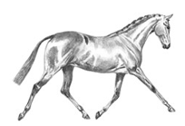
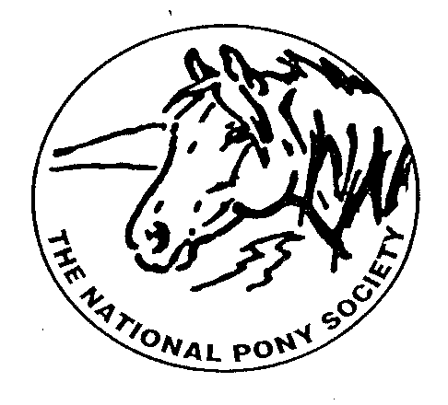
NPS SCOTLAND
MEET OUR BURSARY AWARD WINNERS 2026

The committee of NPS Scotland decided to award the Annual Bursary Awards within the 3 classes of the Junior Ridden section of the NPS Scotland Championships at Scone Palace International Horse Trials.
Our judge Jennifer Adams selected her winner from each class who was then awarded a fabulous sash and a voucher for £150 towards further training and education from NPS Scotland.
3. BURSARY WINNER – Kiara Buchan riding Boothsdale be a Star.
SMALL BREEDS riders under 14 years - Class 26
We wish to first of all thank NPS Scotland for the opportunity of the Training Bursary, it really means alot.
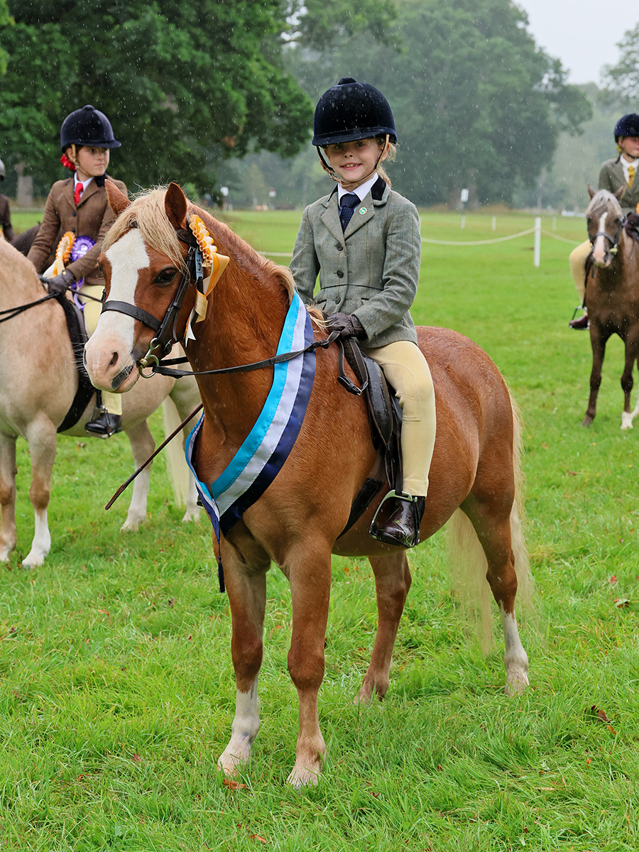
We purchased Boothsdale Be A Star "Denny" as a yearling colt and it has been incredibly rewarding to watch him and Kiara grow and develop into the partnership they are today. We have home-produced Denny throughout his ridden career, learning and progressing together while giving him a varied and enjoyable education.
Over the years, Denny and Kiara have competed in a variety of disciplines and events, including NPS, Working Hunter, British Dressage and Pony Club activities. These experiences have helped to build their confidence, partnership and versatility, while continuing to develop Denny’s skills and Kiara's ability.
They also have regular flatwork lessons with Niamh Meehan, which we intend to continue. The improvement in her quality of riding since beginning these lessons has been outstanding. Niamh has helped her develop a much better understanding of correct flatwork, balance, position and communication with Denny, and this has had a hugely positive impact on their partnership.
We are excited about what the future holds for Kiara and Denny and are keen to continue developing their abilities together. The support of the NPS bursary would be a fantastic opportunity to further their training, gain valuable experience and continue progressing towards their goals while building on the partnership they have worked so hard to create. Thanks again.

