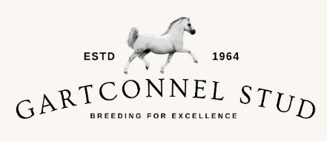
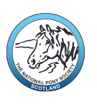
NPS Scotland Educational Stock Judging Day

Gartconnel Stud, Kilearn, Glasgow

Sunday 27th September 2026

We are very grateful to Liz Russell and Louise Jewel for kindly offering their Welsh Pony stud to host this day.

The day is open to members, non-members, and everyone is welcome.

It is designed to be educational and informative as we have a team of experienced judges/producers/trainers who will discuss conformation, breed type, way of going and ways to enhance presentation. This will be relevant to anyone looking to improve their knowledge and production skills across all the M & M breeds.
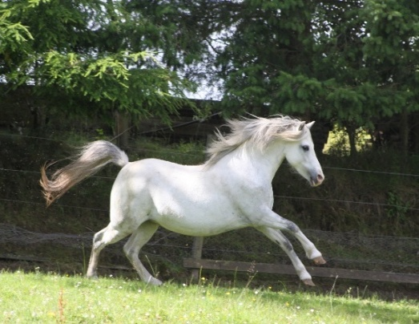
This day will count for CPD with the BHS

Timetable
10.30am Arrive for tea/coffee provided by NPS Scotland
11.00am Using one pony – Instructional discussion on
conformation
David Russell – conformation and breed type
Richard Telford – way of going, presence,
difference in ages
Charlie Cousens– presentation and improvements
11.45am Stock judging (4 x senior ponies) format of ABXY then discussion by judges’ panel
12.15pm Stock judging (4 x Youngstock) format of ABXY then discussion by judges’ panel
12.45pm Break for lunch (Please bring your own lunch, there will be no catering provisions)
1.30pm Championship – 1st & 2nd of both classes. Stock Judge cards.
Open discussion on placings
3pm Finish
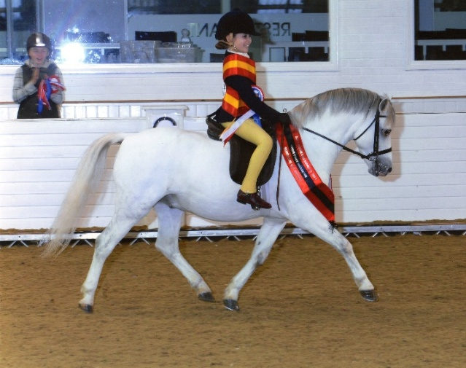
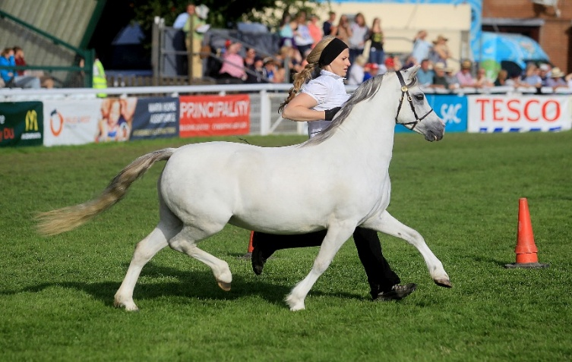
Tickets Tickets £5 via Entrymaster www.npsscotland.co.uk Under 18’s FOC
We need to know numbers and cars to help with parking.

All profits donated to Grass Sickness Research Fund

How to get there
Gartconnel Stud, Carston House, By Kilearn, Glasgow G63 9LJ what 3 words – bikes.afflicted.spectacle

Any questions please contact NPS Secretary Alicia Hay on secretary@npsscotland.co.uk or 07970 816416

