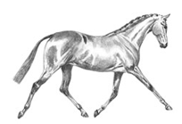
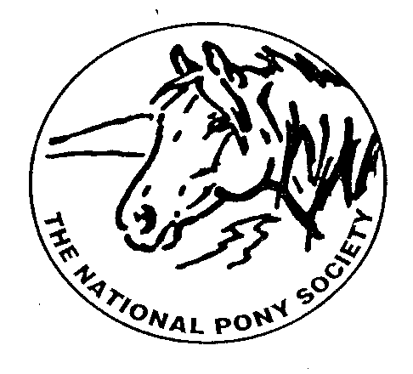
NPS SCOTLAND

MEET OUR BURSARY AWARD WINNERS 2026

The committee of NPS Scotland decided to award the Annual Bursary Awards within the 3 classes of the Junior Ridden section of the NPS Scotland Championships at Scone Palace International Horse Trials.
Our judge Jennifer Adams selected her winner from each class who was then awarded a fabulous sash and a voucher for £150 towards further training and education from NPS Scotland.
1. BURSARY WINNER – Tilly Jardine riding Trailtrow Tianavaig
LARGE BREEDS (exceeding 138cms) riders under 18 years - Class 24
A Season to Remember for Tilly and Tianavaig
Tilly and Tianavaig have enjoyed a truly memorable season, travelling the country and competing at some of the biggest shows on the calendar.
Tilly’s love of Highland ponies began when she was introduced to the breed by Gillian and Kirsten McMurray, the owner and breeder of Tianavaig. It was through them that Tilly discovered her passion for these special ponies, and that connection has grown into a real love for the breed and a successful partnership with Tianavaig.
Their season got off to a fantastic start with success at the Scottish Friends Show in May, followed by appearances at the D&G Horse Show, Royal Highland Show, Derbyshire Show and NPS Summer Championships. Each show brought new experiences and achievements, but it was their final outing of the season at Scone that provided the perfect finale.
Competing in the NPS Scotland / Maggie May Junior Ridden Final, Tilly and Tianavaig produced a brilliant performance to win their class and take Reserve Champion. Their success continued later in the day when Tilly was invited forward for the overall Silver Medal Ridden Championship. Riding against the adults, she once again impressed the judges, securing another Reserve Championship.
The excitement didn’t end there. At the very end of an already long day, Tilly entered the ring for the Overall Supreme of Show, judged by Olympic event rider Oliver Townend. From a strong field, Oliver selected just three competitors to ride an individual show — and Tilly and Tianavaig were among them.
Tilly rode beautifully, showcasing the partnership they have built throughout the season. By this point, however, Tianavaig had understandably spent most of her fuel after such a long and successful day!
Away from the show ring, Tilly is also an active member of Dumfriesshire Hunt Pony Club, where she continues to develop her riding and experience across different disciplines. Her involvement in both showing and Pony Club reflects her enthusiasm for learning and her ambition to keep progressing as a young rider.
Winning the bursary is a fantastic way to round off what has been an exceptional season for Tilly and Tianavaig. The award will go towards a training camp at Somerford Park in the spring, providing an opportunity to continue learning, developing and building on everything they have achieved this year.
It has certainly been a season to remember — and an exciting foundation for what lies ahead for Tilly and her showing career.
Thanks again for this wonderful award.



